**Comfort, Comforting someone**

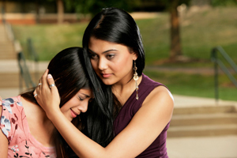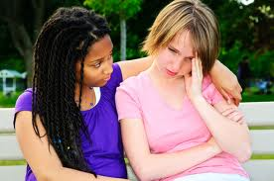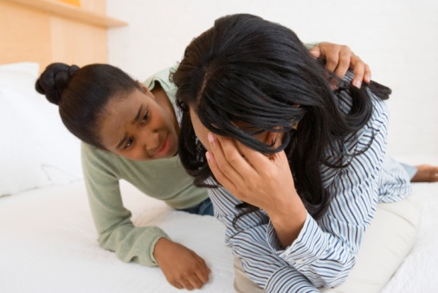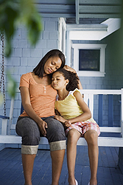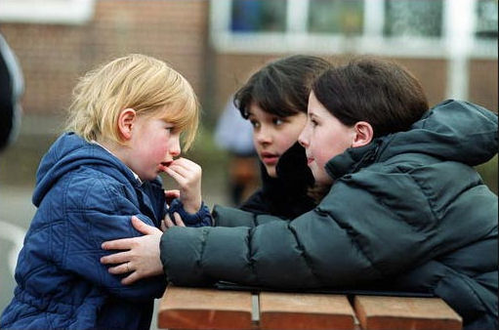

**Mention**

1. **Mention, means to speak about it**

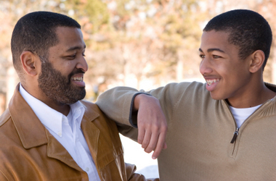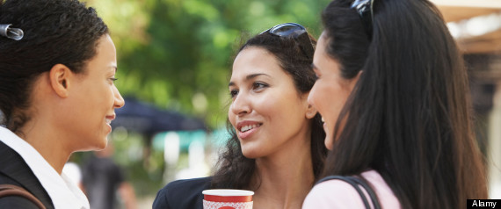

1. **“Please don’t mention it” (means “please don’t speak about it”)**

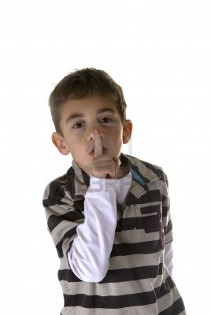

1. **“Don’t mention it” (means “no problem” or “you are welcome”)**

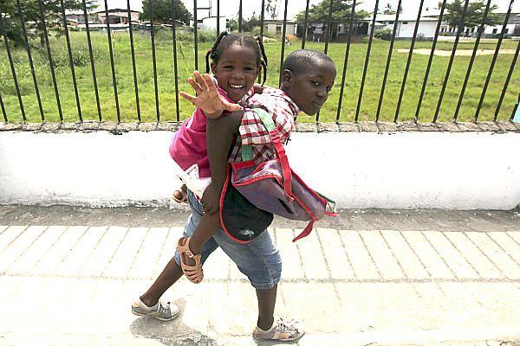

**Mood**

**(the way a person is feeling)**

1. **Happy mood**

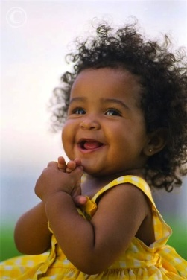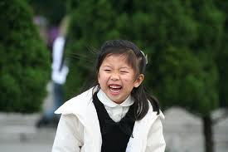

1. **Sad mood**

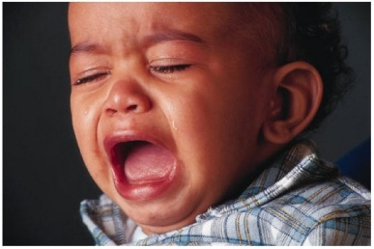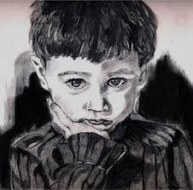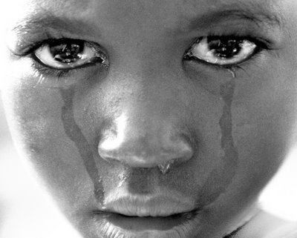

1. **Mad mood**

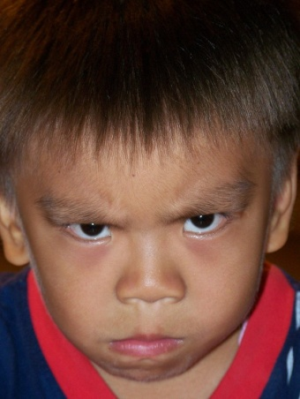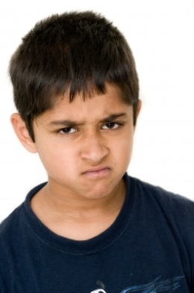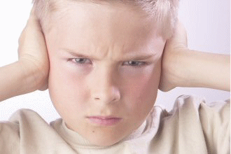

**Properly**

**to do something the right way**

**Improper, (NOT proper) ☹ Proper ☺**

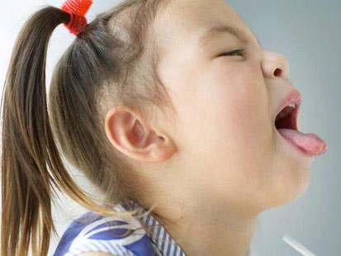 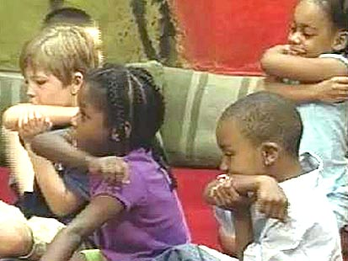

**Improper, (NOT proper) ☹ Proper ☺**

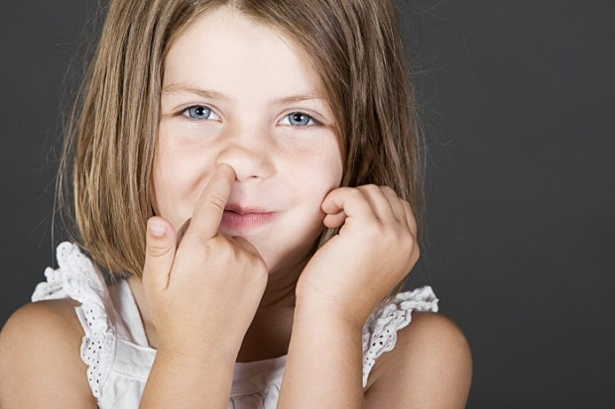 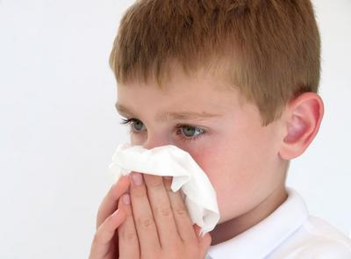

**Improper, (NOT proper) ☹ Proper ☺**

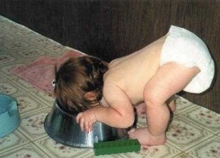 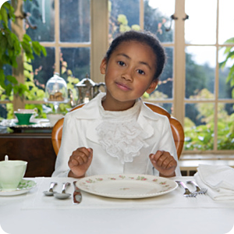

**Intend**

**To plan to do something**

**Things I intend to do… (things I plan to do)**

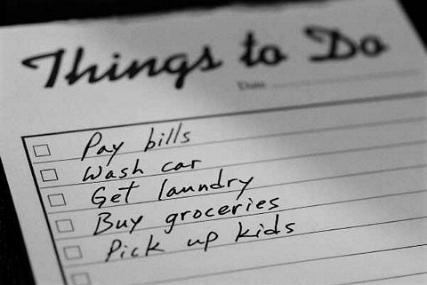

**I intend to keep my promise (I plan to keep my promise)**

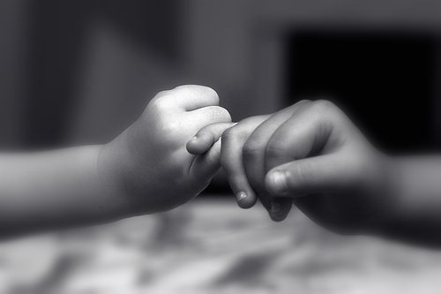

**We intend to get married (we plan to get married)**

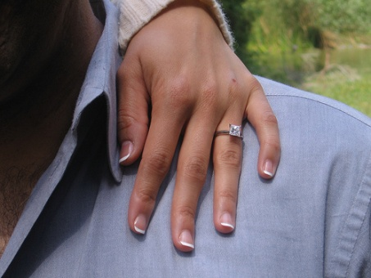

**I’m sorry, I didn’t intend to make a mess (I didn’t plan to make a mess)**

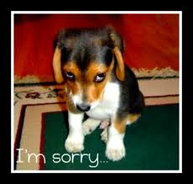**Consists**

**Made up of parts**

**A bike consists of many parts A car also consists of many parts**

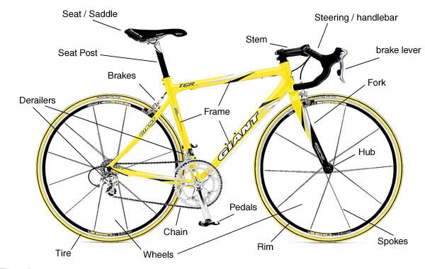 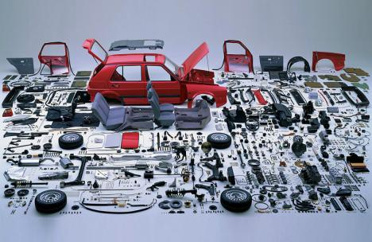

**A computer consists of a base unit, monitor, keyboard, mouse, and printer.**

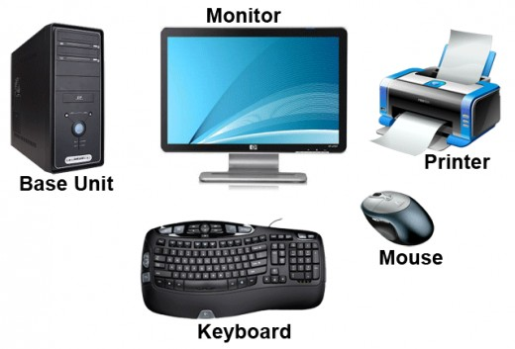

**A book consists of a cover, spine, pages, and a title.**

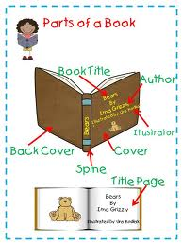

**Positive**

**To be sure**

**This cat is positive she will catch the mouse.**

**This cat is positive she will catch the fish.**

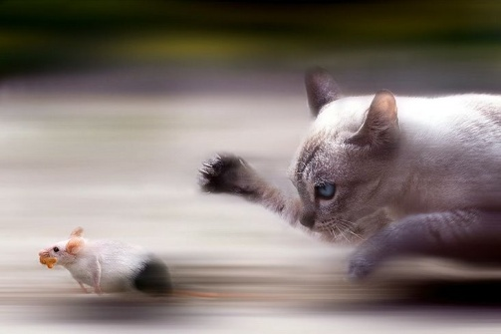 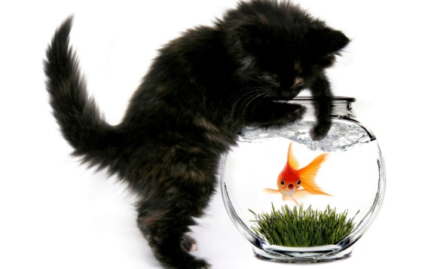

**I am positive this is President Obama.**

**I am positive this is Justin Beiber.**

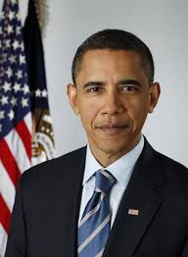 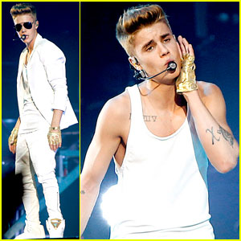

**I am positive this boy loves his dog.**

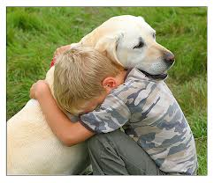

**Advanced**

**Very good at something**

**Tony Hawk has advanced skateboarding skills.**

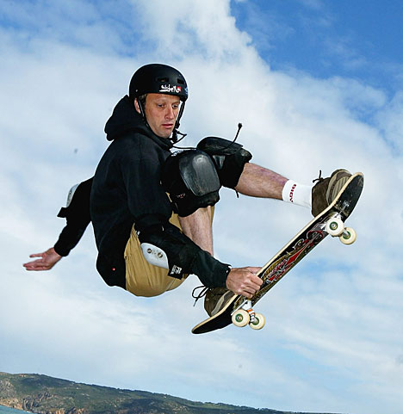

**Gabby Douglas won gold with her advanced gymnastics skills.**

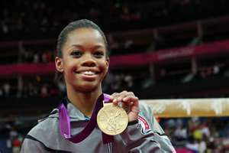

**Beyonce has advanced singing skills.**

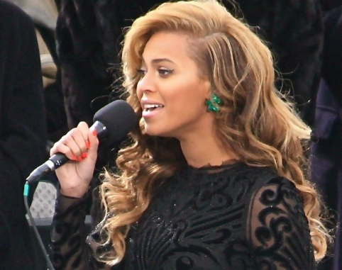

**Michael Jordan has advanced basketball skills.**

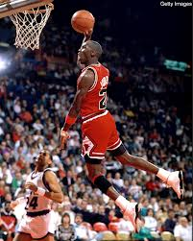

**Peculiar**

**Odd or Unusual**

**Some peculiar shoes….**

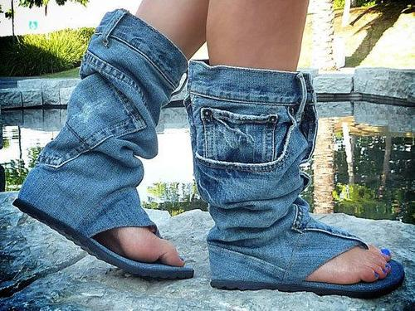 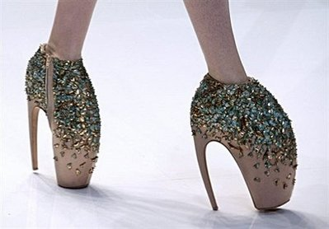 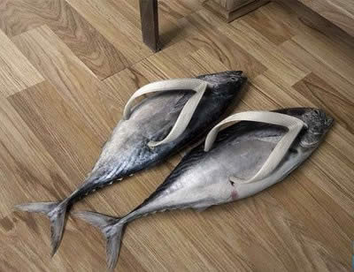

**Some peculiar clothes…**

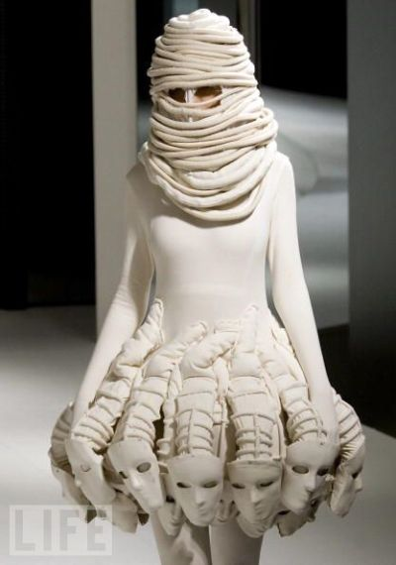 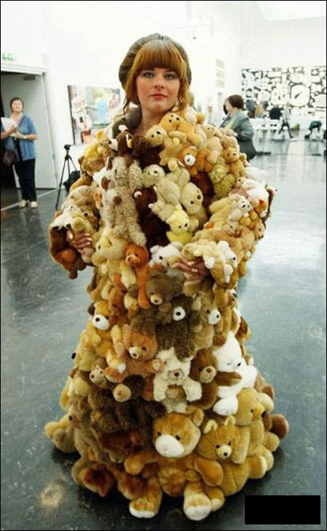 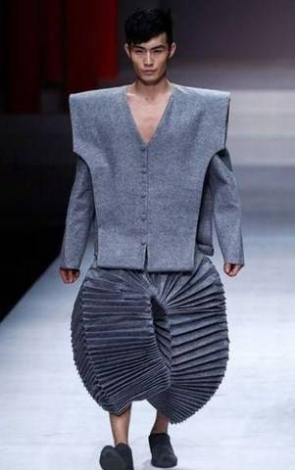

**Some peculiar moustaches….**

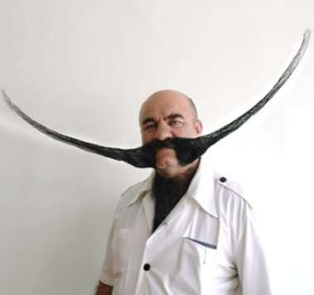 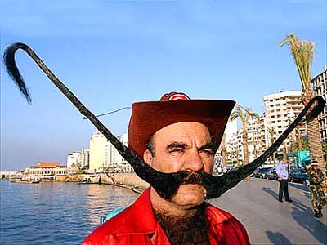 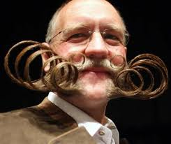

**Talent**

**A special skill**

**Tony Hawk has talent in skateboarding.**



**Gabby Douglas has talent in gymnastics.**



**Beyonce has talent in singing.**



**Michael Jordan has talent in basketball.**

